CAFEPHILE WEBSITE

**A PROJECT REPORT**

***Submitted by***

# TARPADA ISHA DINESHBHAI

**200200107024**

***In partial fulfilment for the award of the degree of***

# BACHELOR OF ENGINEERING

***in Computer Engineering***

***Government Engineering College, Rajkot***



# Gujarat Technological University, Ahmedabad July, 2023

 

# Government Engineering College, Rajkot

**Mavadi-Kankot Road, Near Hanuman Mandir, Rajkot**

**CERTIFICATE**

This is to certify that the project report submitted along with the project entitled **cafephile website** has been carried out by **Tarpada Isha Dineshbhai** under my guidance in partial fulfilment for the degree of Bachelor of Engineering in Computer Engineering, 7th Semester of Gujarat Technological University, Ahmedabad during the academic year 2023-24.

Internal Guide Head of Department

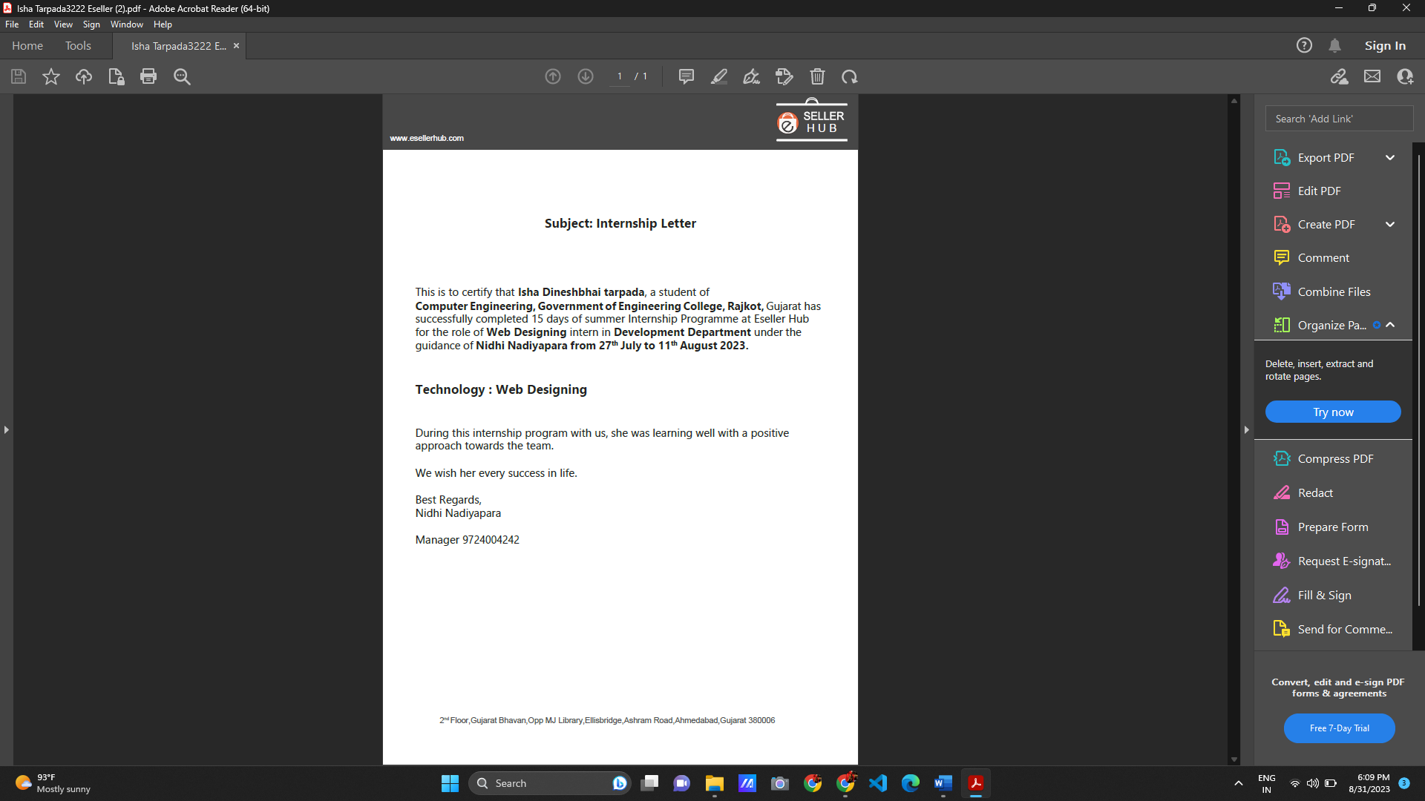

 

# Government Engineering College, Rajkot

**Mavadi-Kankot Road, Near Hanuman Mandir, Rajkot**

**DECLARATION**

I hereby declare that the Internship report submitted along with the Internship entitled **Cafephile Website** submitted in partial fulfilment for the degree of Bachelor of Engineering in **Computer Engineering** to Gujarat Technological University, Ahmedabad, is a bonafide record of original project work carried out by me at **E SELLER HUB.** under the supervision of **Krunal Parmar** and that no part of this report has been directly copied from any student reports or taken from any other source, without providing due reference.

Name of the Student Sign of Student

Isha Tarpada

**Acknowledgement**

I want to thank my supervisor for guiding and supporting me during my internship at E SELLER HUB. They helped me a lot in learning about web development. I am also grateful to the whole team at E SELLER HUB for making the environment great for learning and giving me chances to get hands-on experience.

I want to extend my heartfelt appreciation to **Prof. Jahnvi Doshi** for their guidance, support, and mentorship throughout my internship.

**Abstract**

This report is about my 15-day experience as an intern at E SELLER HUB where I learned about web development. I got to work with different technologies like HTML, CSS. The report provides an in-depth account of my practical experiences and the projects that constituted my internship.

Each chapter of this report sheds light on a distinct aspect of my internship experience. These encompass the creation of an using float property create lapino’z website, create website cafephile , using local storage create change theme of background , and the utilization of the Fetch API to seamlessly integrate external data from a fake store API, and create cart box using local storage .

# Table of Figures:

|  |  |
| --- | --- |
| **Figure No.** | **Page No.** |
| Figure 2.1 | 11 |
| Figure 3.1 | 13 |
| Figure 4.1 | 16 |
| Figure 4.2 | 17 |
| Figure 4.3 | 17 |
| Figure 4.4 | 18 |
| Figure 4.5 | 18 |
| Figure 4.6 | 19 |
| Figure 5.1 | 23 |
| Figure 5.2 | 23 |
| Figure 5.3 | 25 |
| Figure 5.4 | 25 |
| Figure 6.1 | 28 |
| Figure 6.2 | 28 |
| Figure 7.1 | 30 |
| Figure 7.2 | 30 |
| Figure 7.3 | 31 |
| Figure 7.4 | 31 |
| Figure 7.5 | 32 |
| Figure 7.6 | 32 |
| Figure 7.7 | 33 |
| Figure 7.8 | 33 |
| Figure 7.9 |  |
|  |  |

**INDEX**

|  |  |
| --- | --- |
| **Title** | **Page** |
| 1.Introduction | 10 |
| 2.Image-Maping | 11 |
| 3.Create Form | 13 |
| 4.Floate | 15 |
| 5.Position & Display | 20 |
| 6.Grid | 26 |
| 7.Cafephile Website | 30 |
| 8.Local-Storage |  |
| 9.Fake API |  |
| 10.Conclusion |  |
| 11.References |  |

# CHAPTER 1 – INTRODUCTION

I had the opportunity to dive into various technologies such as HTML CSS JavaScript, bootstrap. These technologies serve as the building blocks for modern web development. This chapter sets the stage for the subsequent chapters where I will delve deeper into the specific projects and tasks that I worked on during my internship. It provides a foundation to understand how these technologies come together to create dynamic and interactive web pages. This introduction offers an overview of the skills and concepts that I explored, laying the groundwork for the practical insights I gained throughout the internship.

Our first task was image-mapping. Image map is that you should be able to perform different actions depending on where in the image you click.

In this internship duration I deeply focus on CSS and through the guidance, I learnt create website using CSS and how it is work on e-commerce website learn the basic function for fetch and display API with JavaScript.

# CHAPTER 2: IMAGE_MAPPING

Image mapping in HTML is achieved using the <map> and <area> elements. The <map> element defines an image map, which is a container for clickable areas (hotspots) within an image. The <area> elements define the individual clickable areas and specify the coordinates and shape of those areas on the image.

The <img> tag displays the image you want to make clickable.

The <map> tag with the name attribute defines the name of the image map, which is referenced by the use map attribute in the <img> tag.

The <area> tags define the clickable areas within the image. Each <area> tag has attributes like shape (specifying the shape of the area), coords (specifying the coordinates of the area), href (the URL to link to), and alt (alternative text for accessibility).

There are three supported shapes for the <area> element: rect (rectangle), circle, and poly (polygon). The coords attribute specifies the coordinates for these shapes, and the interpretation of these coordinates depends on the shape.

When a user clicks on one of the defined areas in the image, they will be directed to the specified URL (defined by the href attribute).

Remember to replace "your-image.jpg" with the actual path to your image and update the coordinates and links as needed for your use case.

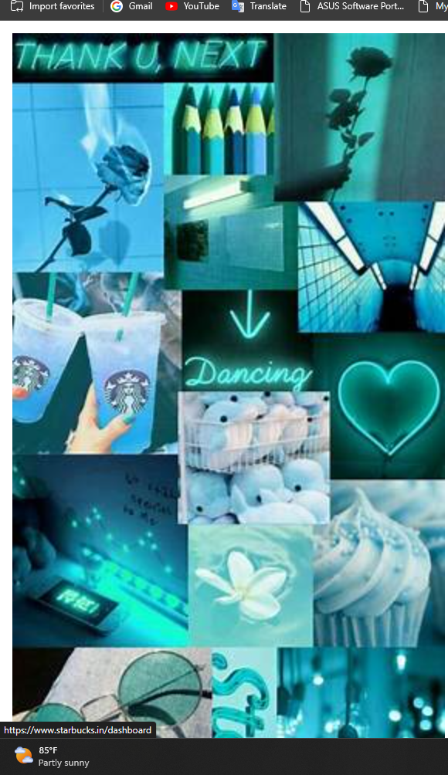

Fig. 2.1

With HTML images maps, we can create clickable areas on an image.

The HTML <map> tag defines an image map. An image map is an image with clickable areas. The areas defined with one or more <area> tags.

In above image, click the glasses image, dance image, and coffee image. And these areas are clickable.

The idea behind an image map is that we should be able to perform actions depending on where in the map you click To Create image map you need an image and some HTML code that describes the clickable areas.

# CHAPTER 3: CREATE A FORM

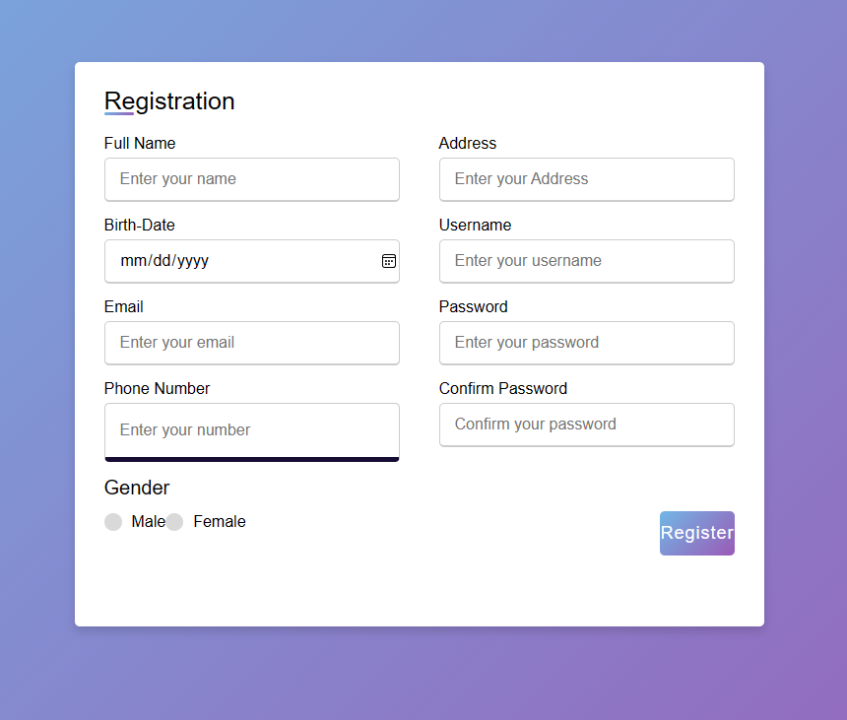

Fig. 3.1

I Create the responsive Registration-form using a HTML and CSS. The registration/signup form contains various input fields of different input details where the user needs to fill in his/her details to submit for a particular web page.

In this, form we give many felids like Full Name, User Name using input type text, Address using input type text area, birth-date using date, Email using input type email, password and confirm-password using email input type, phone-number using input type tele and gender using radio button and register using submit button.

To make this registration form responsive I have used a CSS media query. Also, you have seen how to make a custom radio button and input field of input box animation. and given the background color is linear-gradient. and also register button background color is give the linear-gradient background

When cursor is hover on the input box than input box size is increase and bottom-border is display.

# CHAPTER 4: FLOAT in CSS

In CSS (Cascading Style Sheets), the float property is used to control the positioning and layout of elements within their containing parent element. The float property allows you to make an element float to the left or right of its containing parent element, causing other content to flow around it.

Here's how the float property works:

1. **float: left;** This property value makes the element float to the left within its containing element. Other content (like text or other elements) will flow to the right of the floated element.
2. **float: right;** This property value makes the element float to the right within its containing element. Other content will flow to the left of the floated element.

It's important to note that when an element is floated, it is essentially taken out of the normal document flow. This can have implications for layout and positioning of other elements. To handle the layout properly, it's often necessary to use additional CSS techniques, such as clearing floats, to ensure that subsequent content behaves as expected.

However, over time, the use of the float property has become somewhat outdated for complex layout purposes. Modern CSS layout techniques, like Flexbox and CSS Grid, provide more powerful and flexible ways to create complex layouts without some of the challenges associated with the float property.

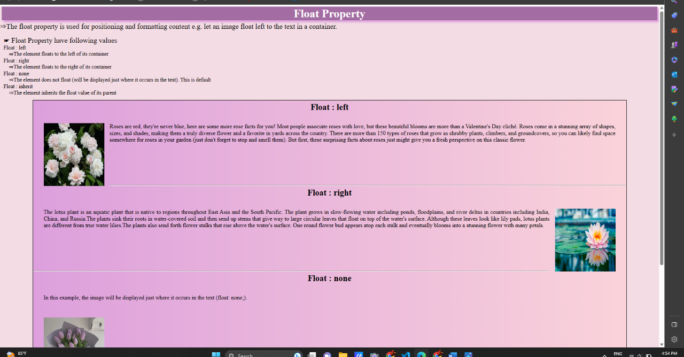

Fig.4.1

# TASK 1: CREATE LAPINO’Z WEBSITE USING FLOAT PROPERY

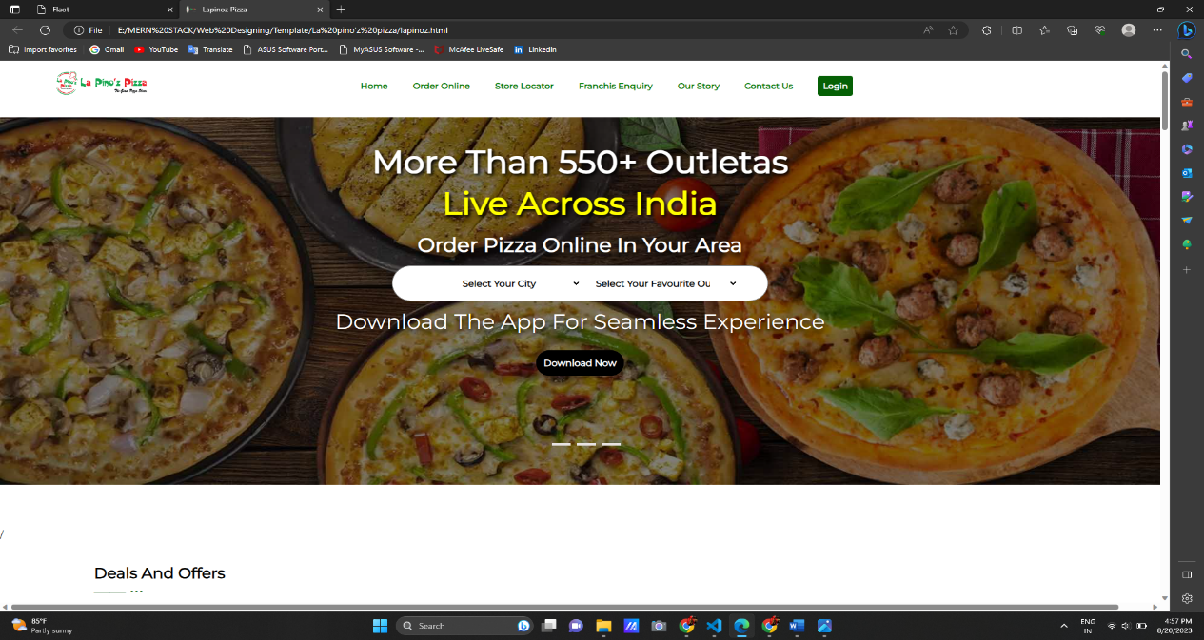

Fig.4.2

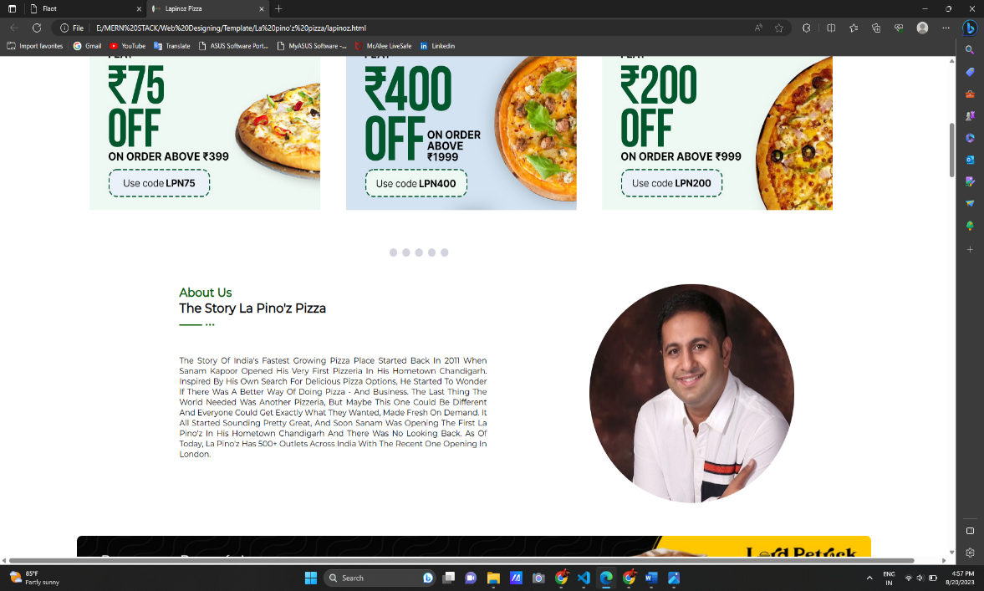

Fig.4.3

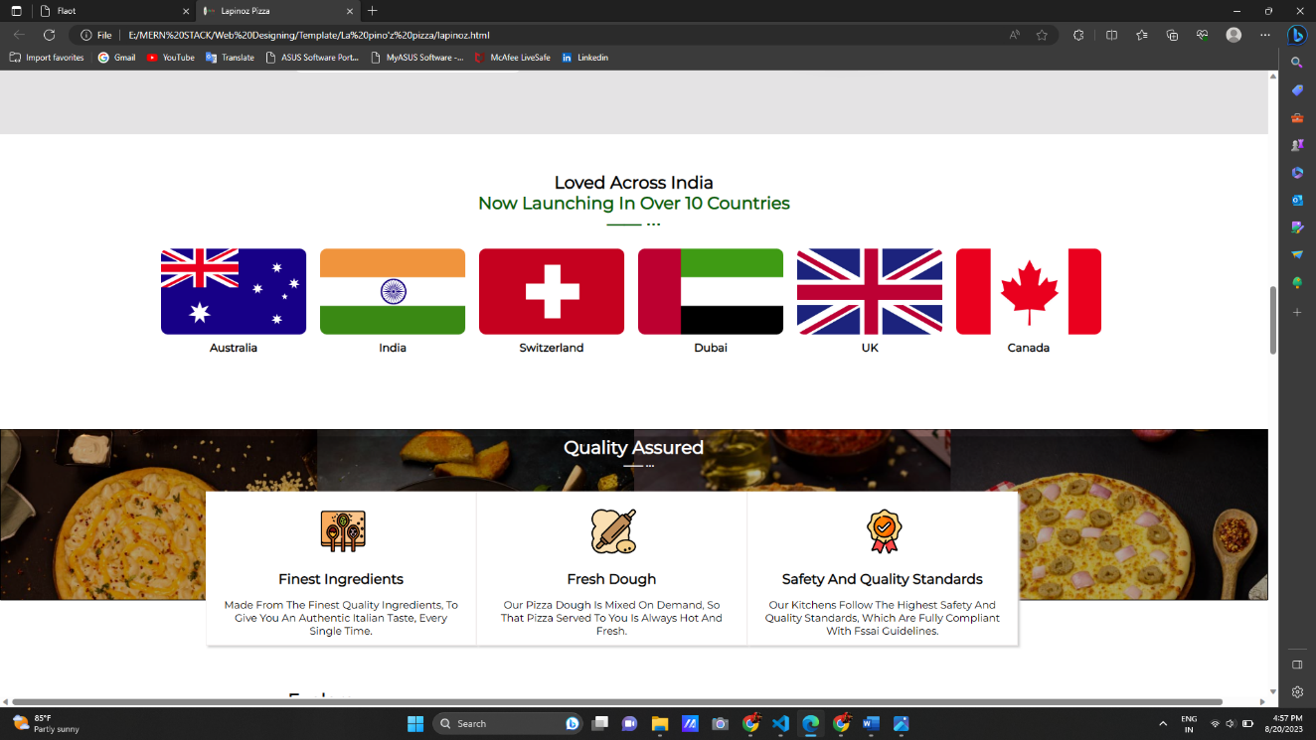

Fig.4.4

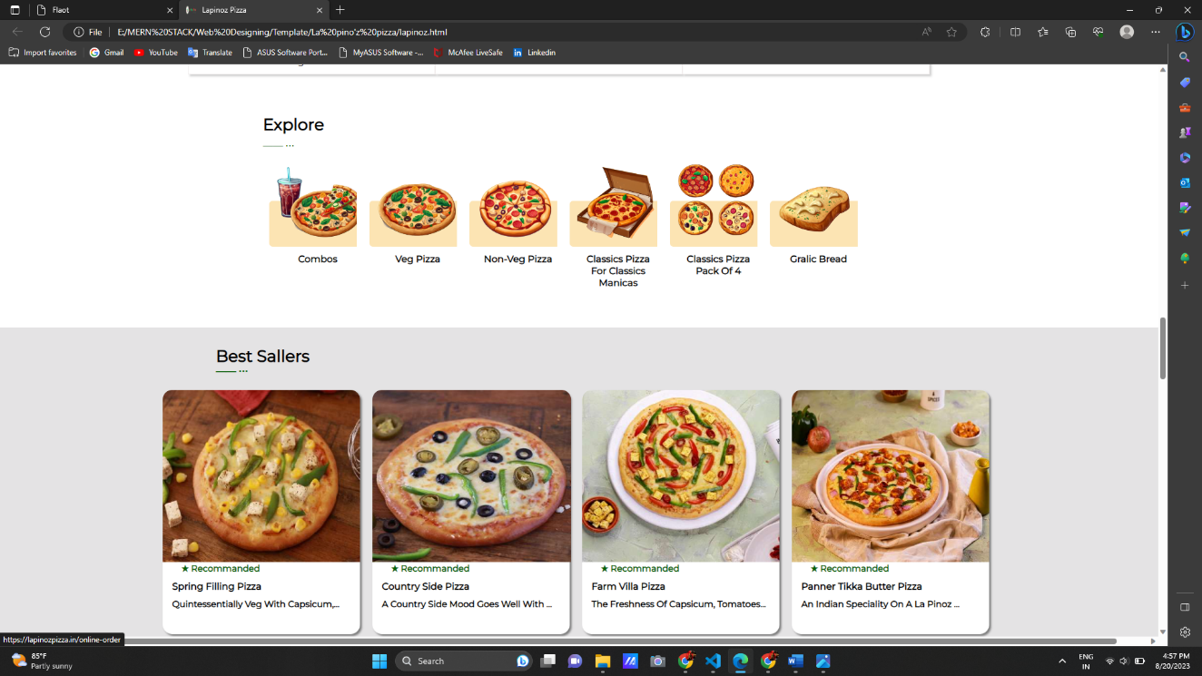

Fig.4.5

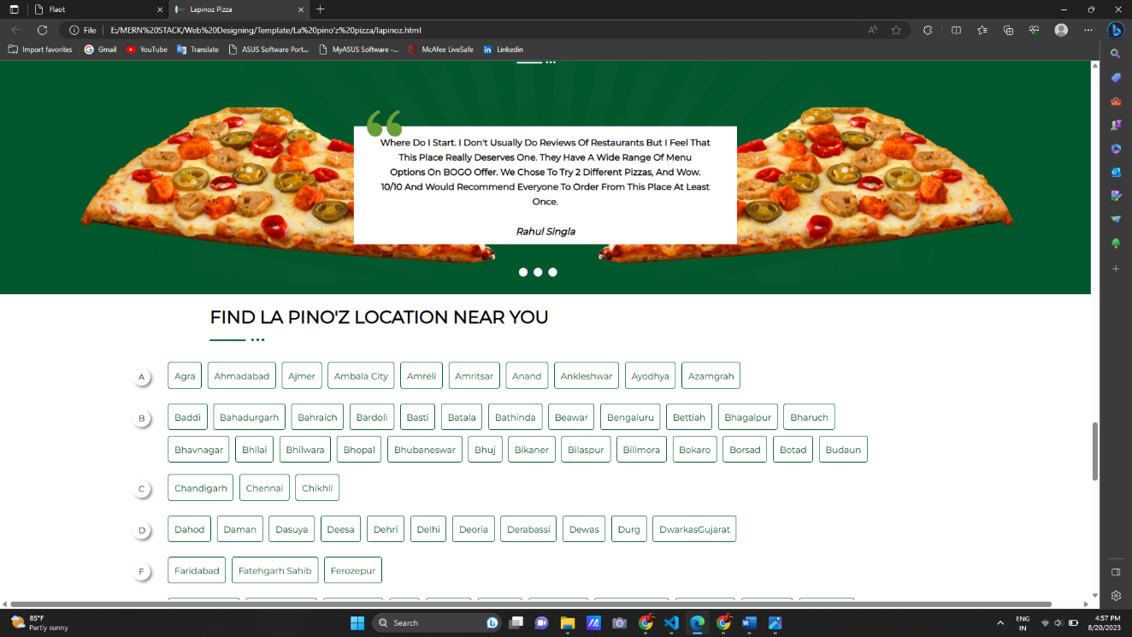

Fig.4.6

In this task, create the website using float property. in this Website only use the float property don’t use the flex and grid property. using the float property on a website. However, please note that the float property is now considered outdated for complex layout purposes due to its limitations and potential challenges. Modern CSS layout techniques like Flexbox and CSS Grid offer better solutions for creating responsive and complex layouts.

It's important to note that when an element is floated, it is essentially taken out of the normal document flow. This can have implications for layout and positioning of other elements. To handle the layout properly, it's often necessary to use additional CSS techniques, such as clearing floats, to ensure that subsequent content behaves as expected.

# Chapter 5: POSITIONS & DISPLAY

Certainly, CSS offers different positioning options to control the layout and positioning of elements on a web page. Here are the key positioning properties in CSS:

1. **Static Positioning (Default)**:
   * **position: static;**

This is the default positioning for elements. Elements are placed in the normal document flow and are not affected by the positioning properties.

1. **Relative Positioning**:
   * **position: relative;**

When an element is positioned relatively, you can adjust its position using **top**, **right**, **bottom**, and **left** properties. The element is still part of the normal document flow, and other elements will behave as if the relative-positioned element is still in its original position.

1. **Absolute Positioning**:
   * **position: absolute;**

Absolute positioning takes an element out of the normal flow and positions it relative to its nearest positioned ancestor (or the viewport if no ancestor has a positioned property). It's commonly used to create overlays or tooltips that appear over other content. The **top**, **right**, **bottom**, and **left** properties are used to position the element.

1. **Fixed Positioning**:
   * **position: fixed;**

Fixed positioning is similar to absolute positioning, but the element is positioned relative to the viewport, even if the page is scrolled. Fixed-positioned elements remain in a fixed position while scrolling, making them useful for headers, footers, or sticky elements.

1. **Sticky Positioning**:
   * **position: sticky;**

Sticky positioning is a combination of relative and fixed positioning. An element with **position: sticky;** will act as relatively positioned until it reaches a specified threshold (usually defined by **top**, **right**, **bottom**, or **left** values), at which point it becomes fixed. Sticky positioning is often used for creating sticky headers or navigation bars.

The **display** property in CSS is used to control how an HTML element is rendered on a webpage. It determines the box type and layout behavior of an element. The **display** property has several values, each affecting the element's behavior in terms of how it takes up space and interacts with other elements. Here are some common values for the **display** property:

1. **block**:
   * The element generates a block-level box.
   * It takes up the full width of its parent container and creates a new line before and after itself.
   * Elements with **display: block;** do not sit beside each other but stack vertically.
2. **inline**:
   * The element generates an inline-level box.
   * It only takes up as much width as necessary and doesn't start on a new line.
   * Elements with **display: inline;** can sit beside each other horizontally.
3. **inline-block**:
   * The element generates a block-level box, but it behaves like an inline-level element in terms of layout.
   * It takes up only as much width as necessary, and multiple **inline-block** elements can sit beside each other horizontally.
4. **none**:
   * The element is not displayed at all.
   * It doesn't take up any space, and the element's content is removed from the layout flow.
5. **flex**:
   * The element generates a flexible container, enabling easy manipulation of its child elements using Flexbox properties.
   * It allows for easy distribution of space and alignment of child elements.
6. **grid**:
   * The element generates a grid container, enabling layout using CSS Grid properties.
   * It provides a powerful way to arrange elements in rows and columns.
7. **table**, **table-row**, **table-cell**, **table-header-group**, etc.:
   * These values are part of the CSS display properties that simulate table behavior for creating table layouts.
8. **inherit**:
   * The element inherits the **display** value from its parent.
9. **initial**:
   * The element uses the default **display** value for its type.
10. **unset**:
    * The element uses the default **display** value for its type, but if the property is not set on a parent, it behaves as **inherit**.

# TASK-1 CREATE HEADER AND BANNER IMAGE

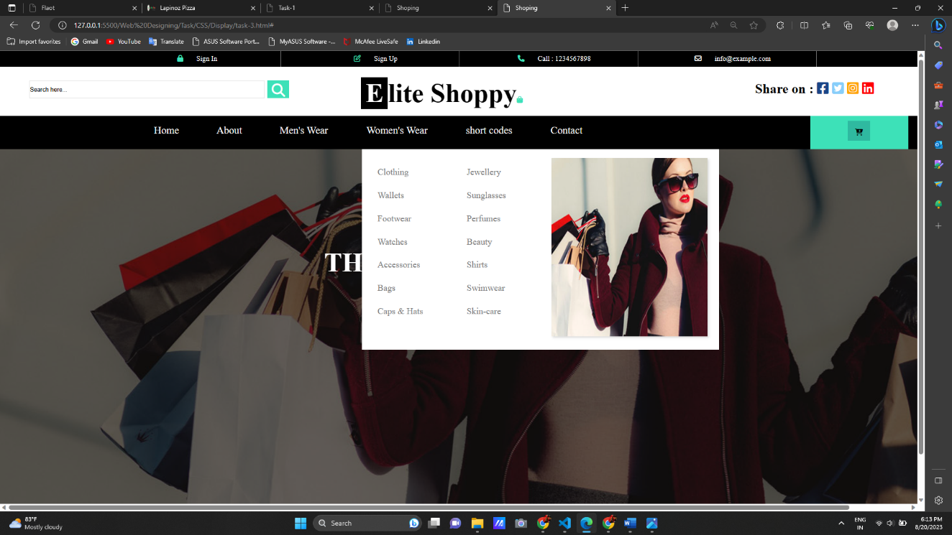

Fig.5.1

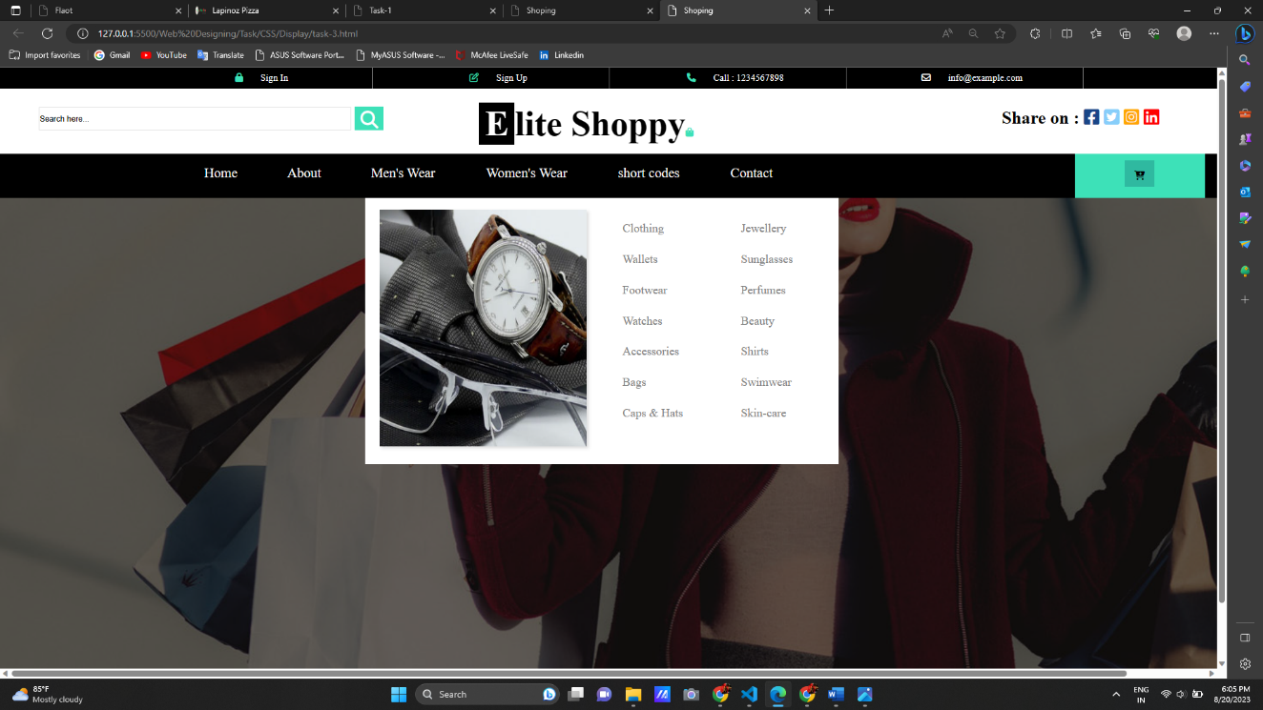

Fig.5.2

In This Task, create header section using display and position property. in this task create three headers. in First header we add a sign-in, sign-up, contact-info and mail-information. Second header we add search bar option which is used A search bar is commonly placed prominently in the header to allow users to search for specific products or categories. Then add website logo and share this website different apps. And third header shows the menu bar list in this list in another list.

**TASK-2 SLIDE THE IMAGE WITHOUT USING ANIMATION**

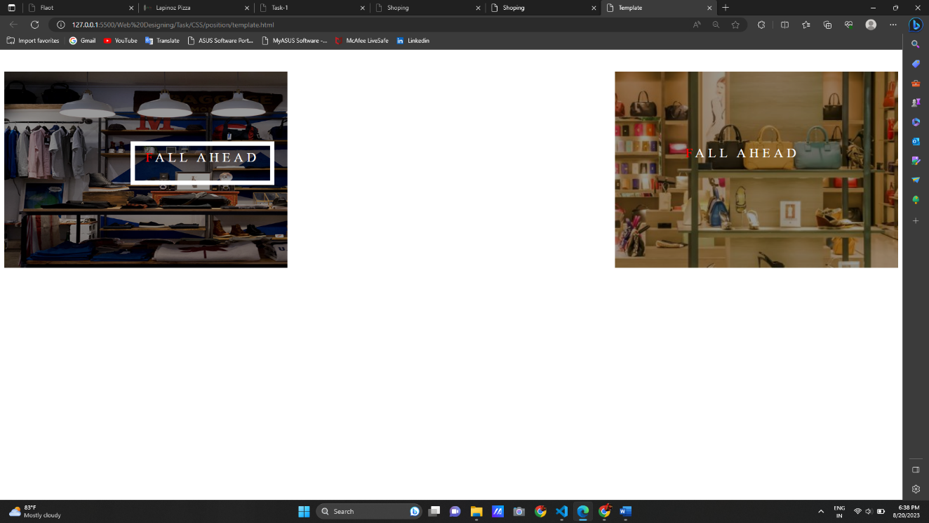

Fig.5.3

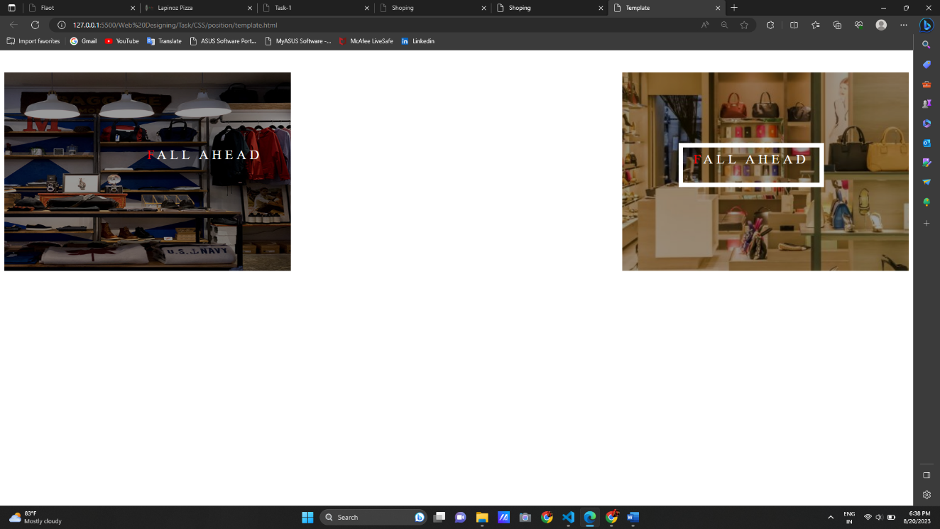

Fig.5.4

In this task, slide the image without using animation. Main div box position is relative and text box and another div box position is absolute and adjust using left, right, top, bottom property. In this task when mouse is hovering the container box when image is the slide the right side with using position Relative and Absolute. when mouse is hovering the text than text border is display using transition property.

# Chapter 6: GRID

The CSS Grid Layout, commonly referred to as "CSS Grid," is a powerful layout system in CSS that allows you to create complex two-dimensional layouts with rows and columns. It's designed to provide precise control over the placement and alignment of elements within a container. Here's a brief overview of CSS Grid properties and their functionality:

1. **display: grid;**
   * This property turns an element into a grid container, creating a new grid formatting context.
   * It enables the use of other CSS Grid properties to define the layout.
2. **grid-template-columns** and **grid-template-rows**:
   * These properties define the size and structure of the grid's columns and rows, respectively.
   * You can use values like fixed sizes (px, em), relative sizes (fr for fractions), and keywords (**auto** for automatic sizing).
3. **grid-template-areas**:
   * This property allows you to create named grid areas within the layout.
   * You define the grid structure using custom names, and then assign those names to elements using the **grid-area** property.
4. **grid-gap**:
   * This property sets the size of the gaps between grid cells (both rows and columns).
   * It's a shorthand for **grid-row-gap** and **grid-column-gap**.
5. **grid-row** and **grid-column**:
   * These properties control how an item is placed within the grid by specifying its start and end positions along rows and columns.
   * You can use numeric values, named lines, or keywords like **span** to define the size and position of an item.
6. **grid-area**:
   * This property specifies the grid area an item occupies, using the name of a grid area defined by **grid-template-areas**.
7. **justify-items** and **align-items**:
   * These properties control the alignment of items within their respective cells along the horizontal and vertical axes.
8. **justify-content** and **align-content**:
   * These properties control the alignment of the entire grid within its container along the horizontal and vertical axes.
9. **place-items** and **place-content**:
   * These properties are shorthand for setting both **justify-items** and **align-items**, and **justify-content** and **align-content**, respectively.
10. **grid-auto-columns** and **grid-auto-rows**:
    * These properties define the size of implicit rows and columns that are created when an item is placed outside the explicitly defined grid.
11. **grid-auto-flow**:
    * This property controls the direction in which items are added to the grid (either rows or columns) when they exceed the explicit grid's dimensions.

CSS Grid provides a highly flexible and intuitive way to design layouts, making it easier to create responsive and complex designs without relying on excessive nested HTML elements or complex CSS positioning. It's particularly useful for building grids, card layouts, responsive designs, and more.

Top of Form

**TASK-1 CREATE PHOTO GALLERY USING GRID WITH RESPONSIVE**

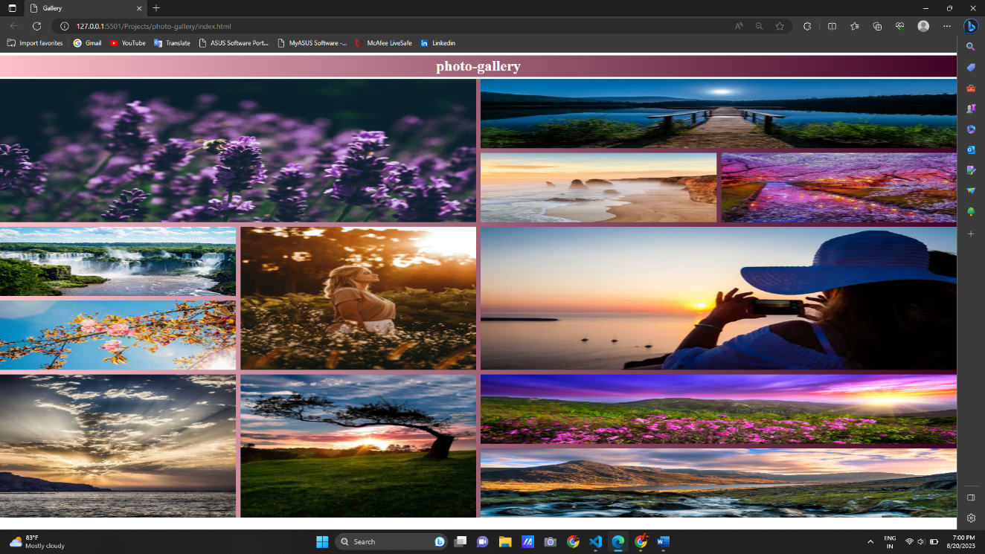

Fig.6.1

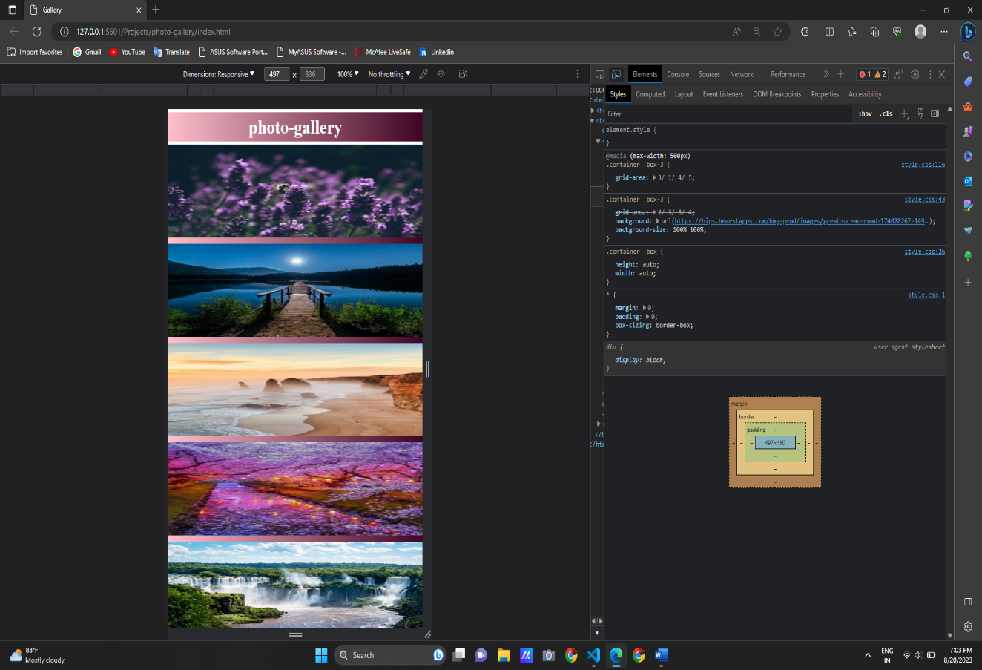

Fig.6.2

1. In the HTML, we've set up a basic structure for the photo gallery using a **div** with the class "gallery". Inside this div, we have multiple **div** elements with the class "item", each containing an image.
2. In the CSS, we define the styles for the gallery and its items. We use the CSS Grid layout to create a flexible grid with responsive columns. The **repeat(auto-fit, minmax(...))** technique ensures that the columns adjust based on the available space.
3. The **gap** property adds spacing between the items in the gallery.
4. Each "item" div contains an image. We set **max-width: 100%** on the image to ensure it scales down responsively according to its container's width.
5. For smaller screens, we use a media query (**@media**) to adjust the grid layout to accommodate smaller devices. This ensures that the gallery remains visually appealing and functional on different screen sizes.

# CHAPTER 7: CAFEPHILE WEBSITE

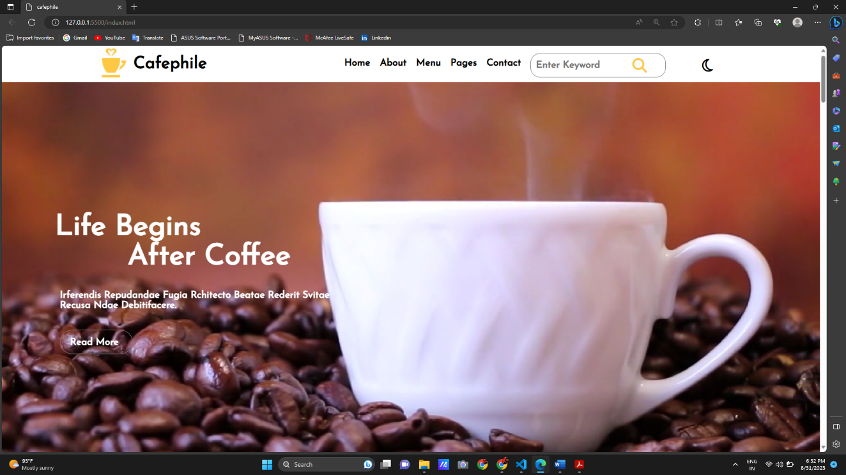

Fig.7.1

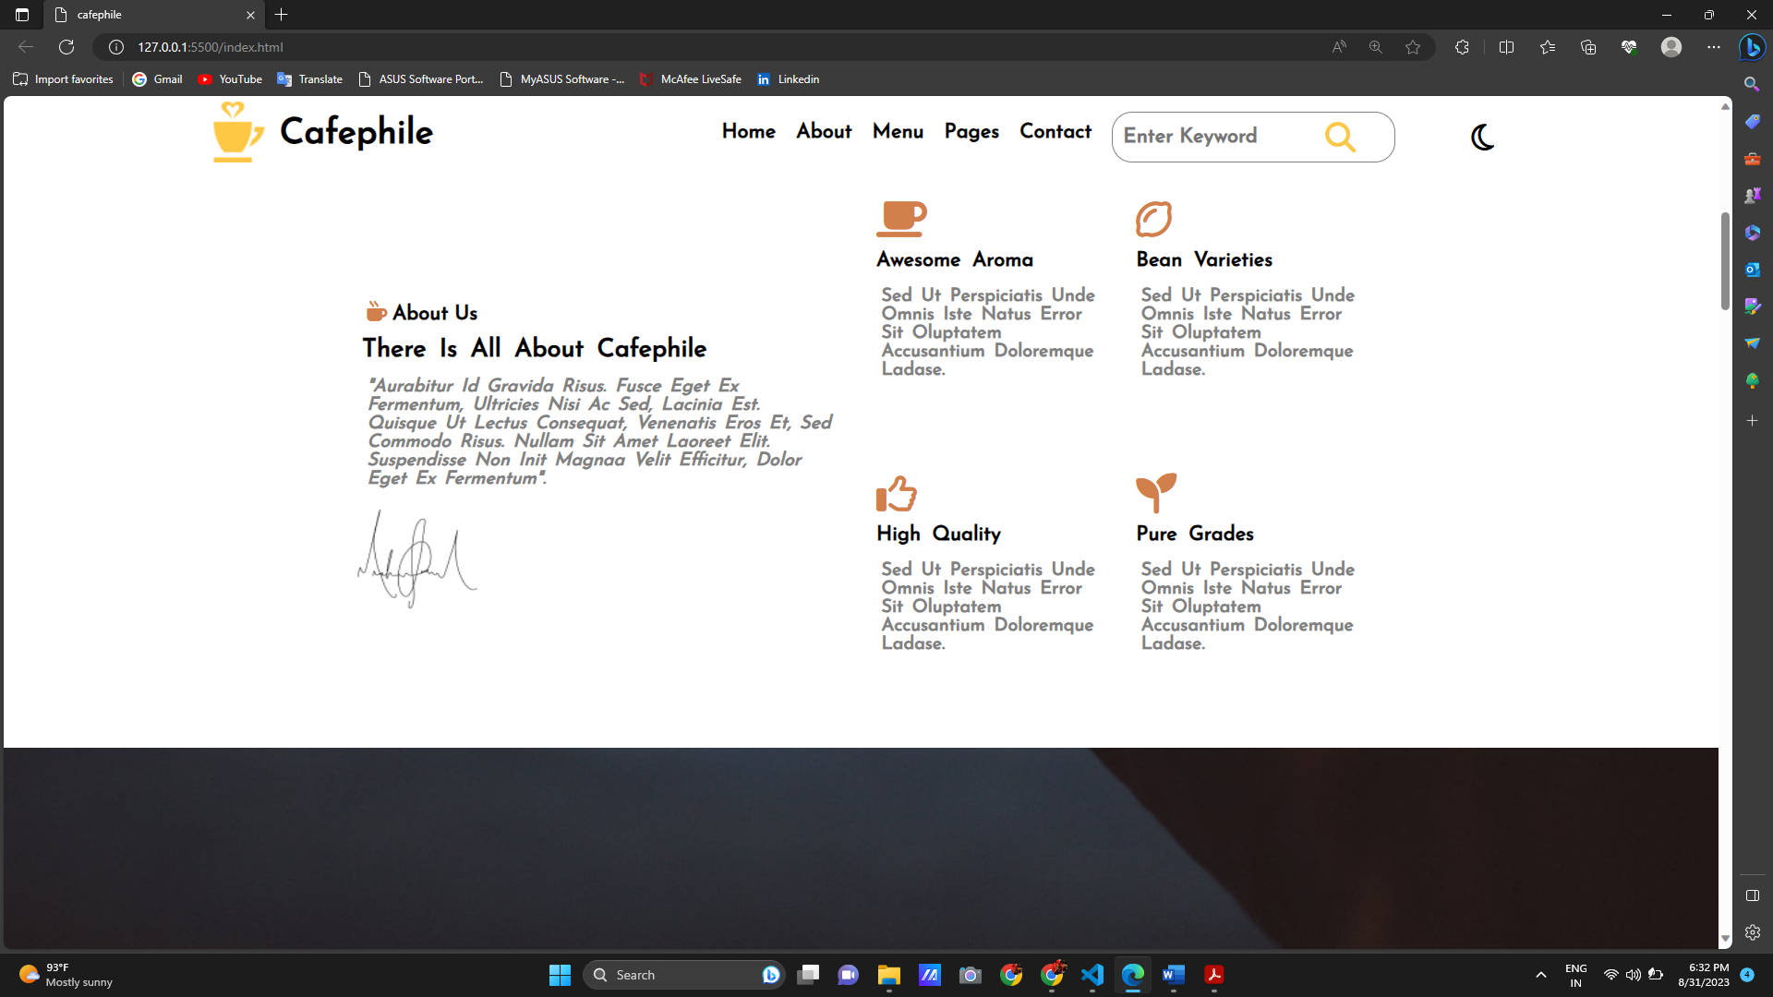

Fig.7.2

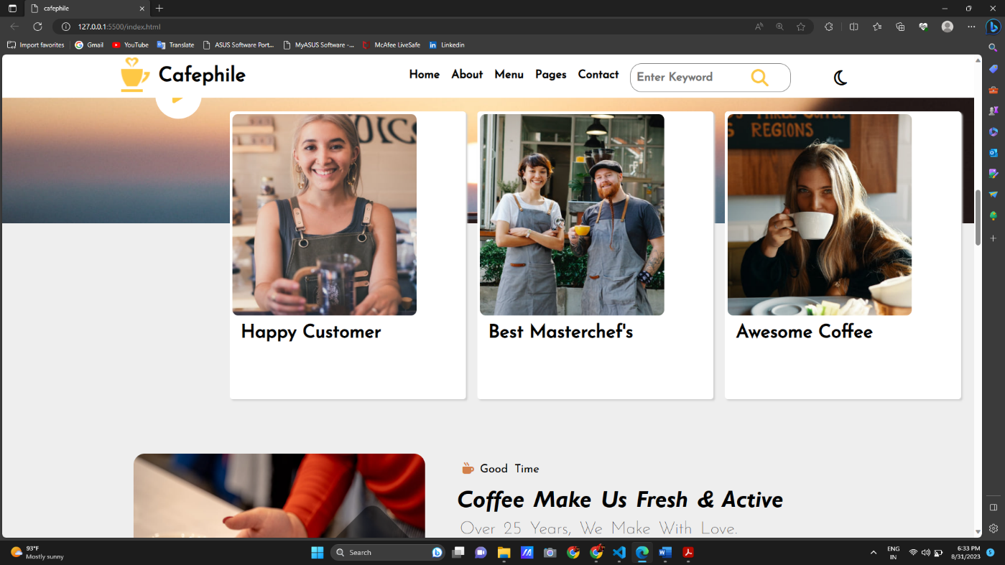

Fig.7.3

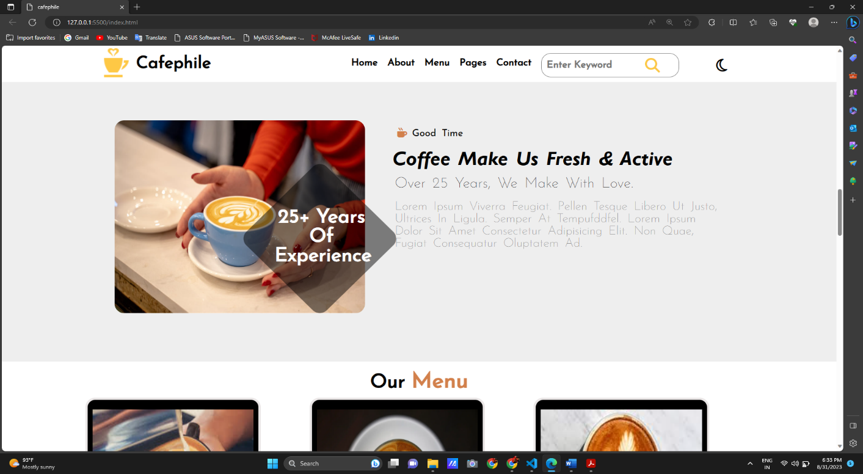

Fig.7.4

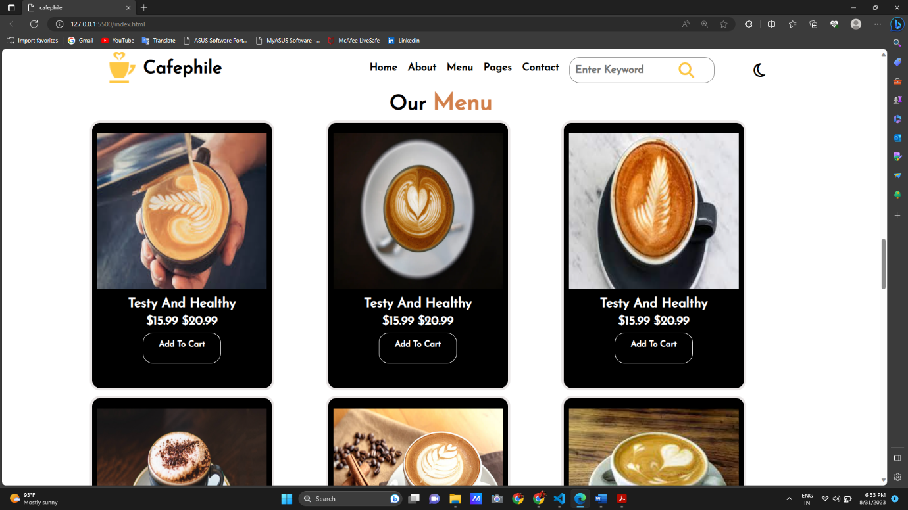

Fig.7.5

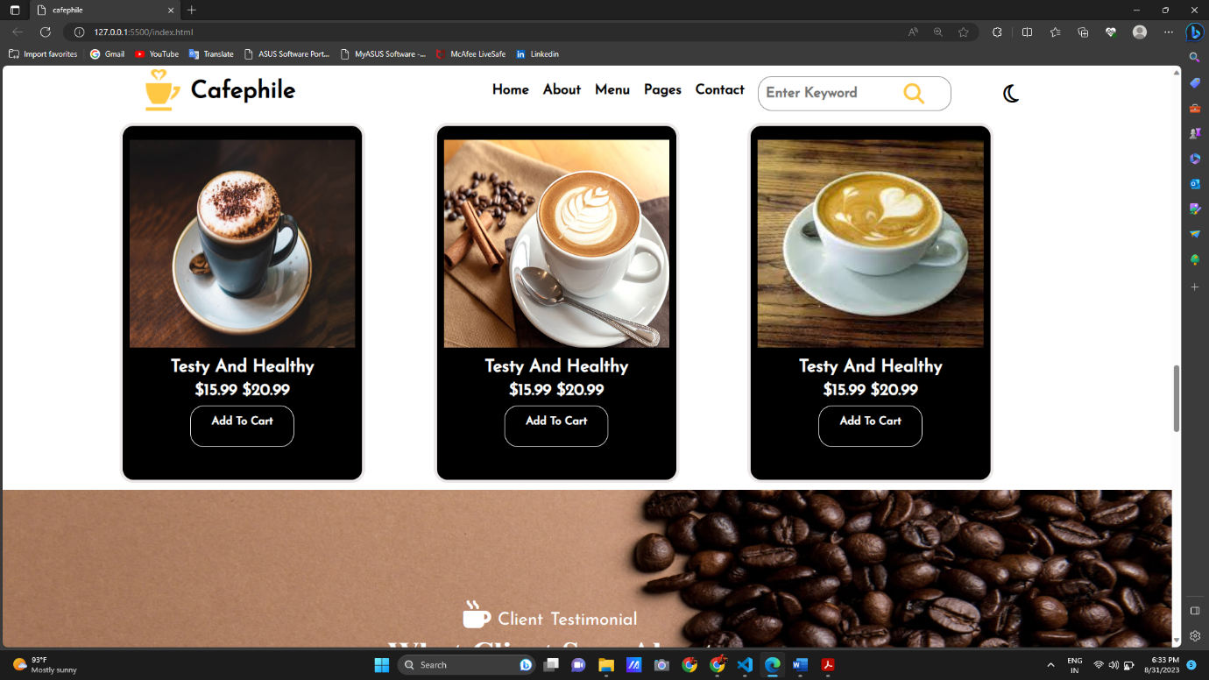

Fig.7.6

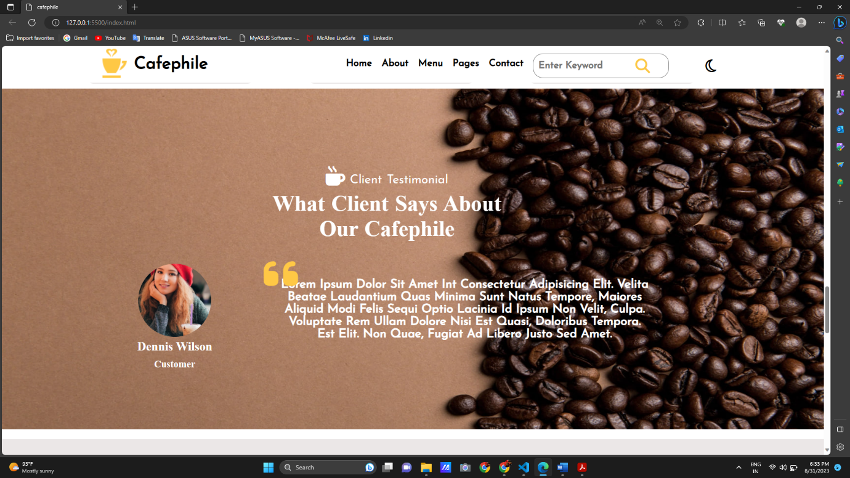

Fig.7.7

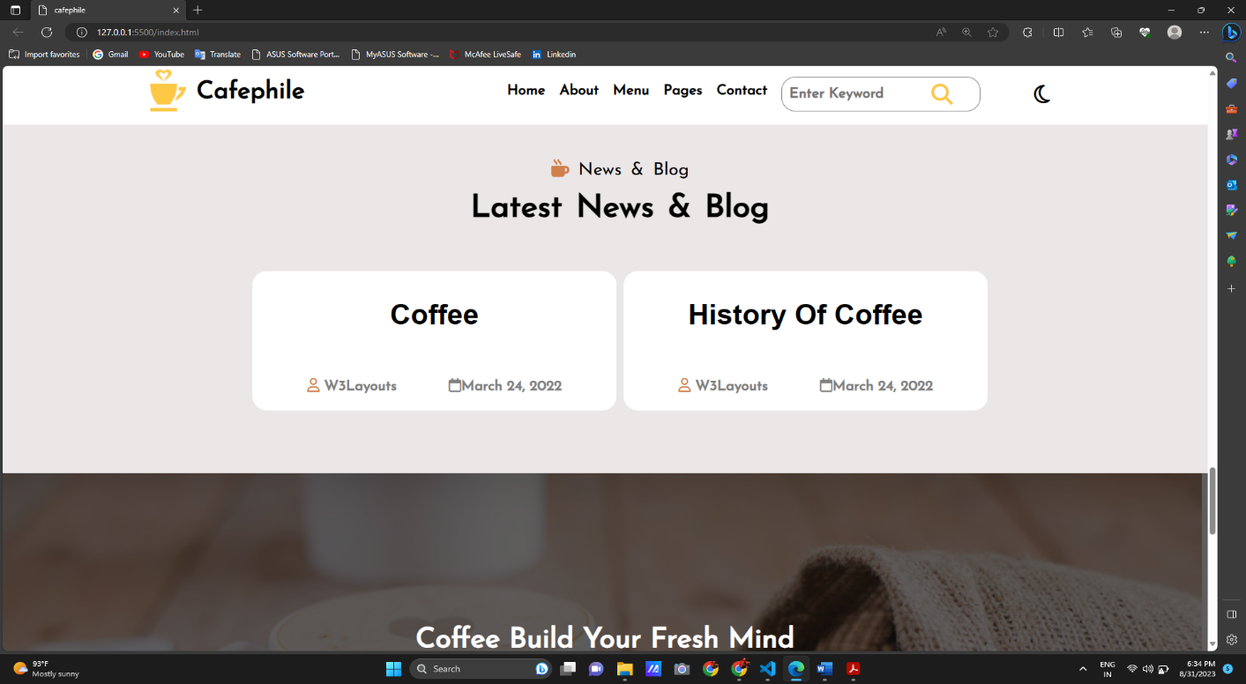

Fig.7.8

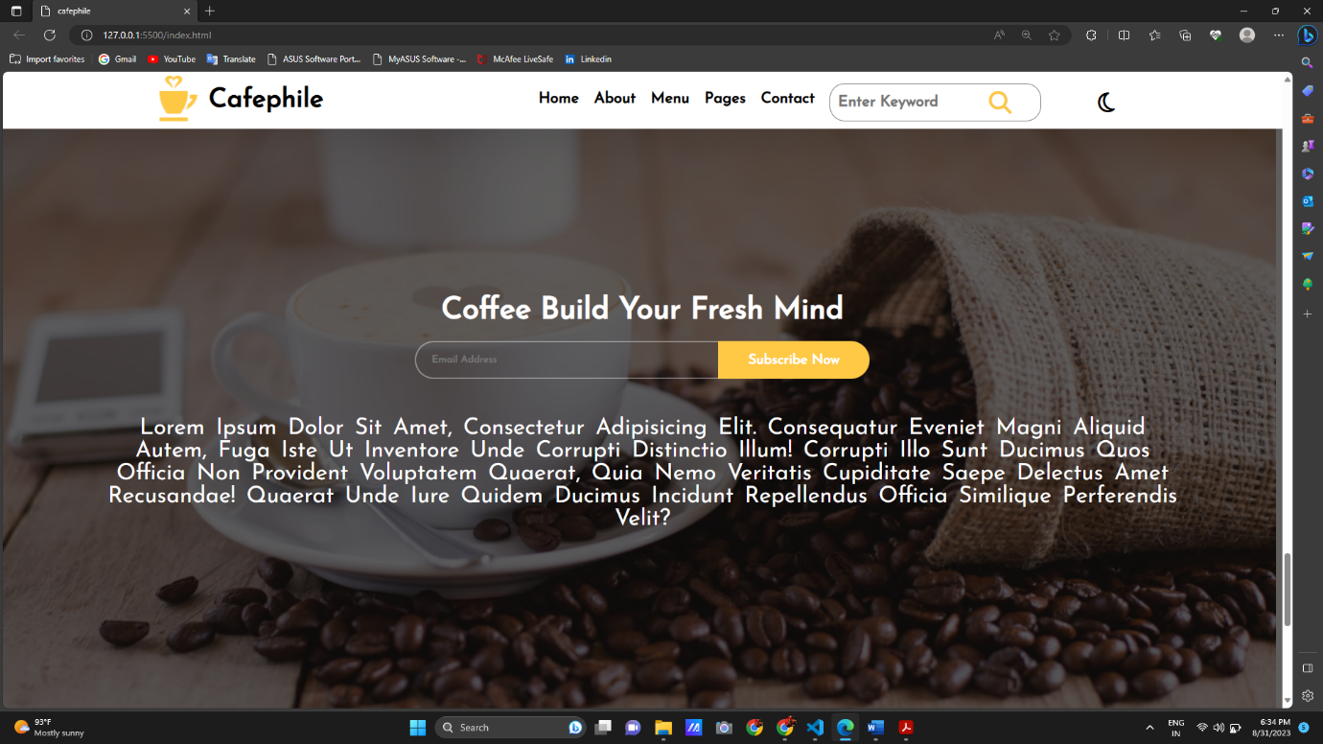

Fig 7.9

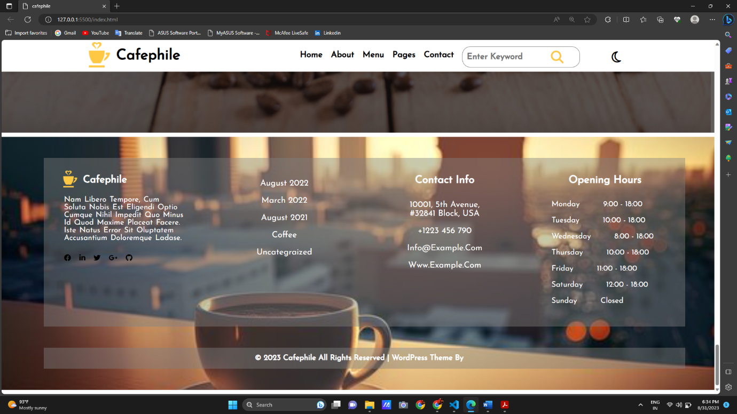

Fig 7.10

cafephile website is developed based on the HTML, CSS and Local Storage.

in this website main functionality is the add to cart button.

In this website I had added the header this header is fixed position at the top position.

banner image and banner text using position property. Create the why we are unique section and create the div costumer, MasterChef’s box. In this section background is fixed using the background-attachment property. and play button create the font-awesome icons and hover effect.

Then create the about-us section and information section are designed and this section is

Designed using grid property.

Then designed our menu section and this section main functionality is item is adding the local storage.

Then last designed the footer and client review section.

In this main page, I had added nav-bar, cards and some CSS functionalities like label and transition buttons and readers would gain insights into the creative and technical decisions that culminate in a user-centric online shopping experience. Through the design considerations that underpin a successful ecommerce main page – from layout and visual elements to interactive features that enhance user experience.

• The "Add to Cart" button facilitates the inclusion of product details in the user's local Storage, enabling them to construct a personalized shopping cart.

• A dynamic cart badge discreetly displays the number of items within the user's cart.

• The delete icon button within the cart view grants users the ability to effortlessly remove Items from their selections.

• Streamlined navigation is provided through a dropdown menu, allowing users to swiftly access various product categories.

• The presence of discount badges draws attention to products currently offered at reduced prices.

# CHAPTER 8 – LOCAL STORAGE

In JavaScript, local storage is a web browser feature that allows you to store key-value pairs of data locally on the user's device. You can use the **localStorage** object to interact with this local storage mechanism. Here's how you can use **localStorage** in JavaScript:

1. **Storing Data:**

You can store data in local storage using the **setItem** method. This method takes two parameters: the key and the value you want to store.

localStorage.setItem('username', 'john_doe');

1. **Retrieving Data:**

To retrieve data from local storage, you can use the **getItem** method and provide the key of the data you want to retrieve.

const username = localStorage.getItem('username');

console.log(username); // Output: "john_doe"

1. **Removing Data:**

You can remove data from local storage using the **removeItem** method and passing the key of the data you want to remove.

localStorage.removeItem('username');

1. **Clearing All Data:**

You can clear all the data stored in local storage using the **clear** method.

localStorage.clear();

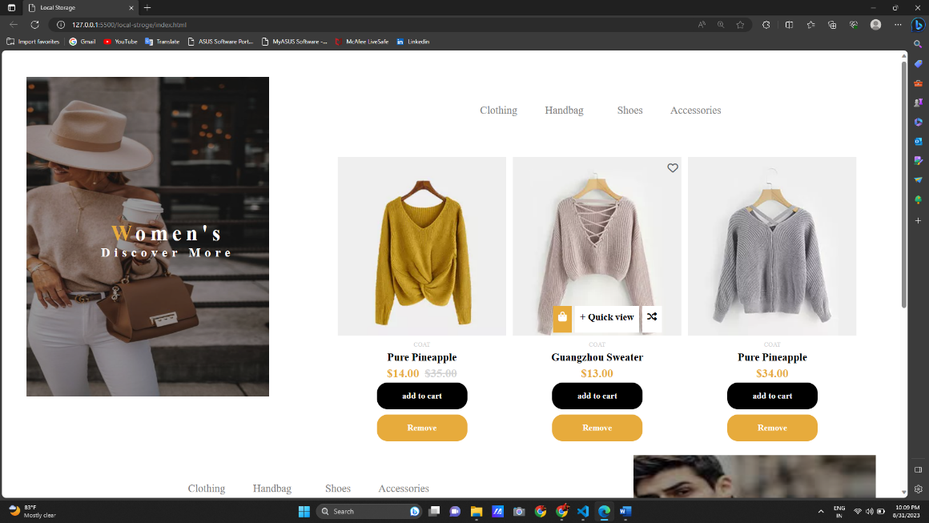

Fig 8.1

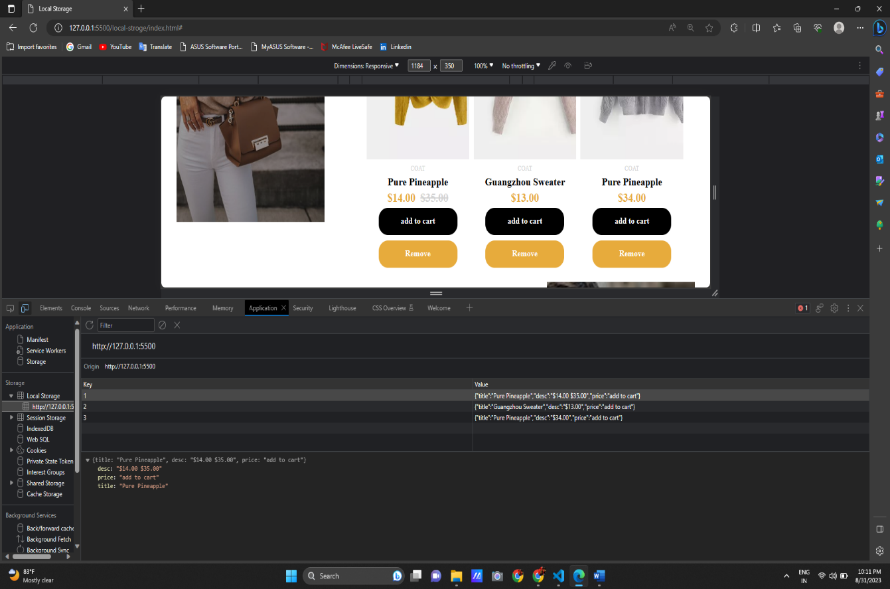

Fig 8.2

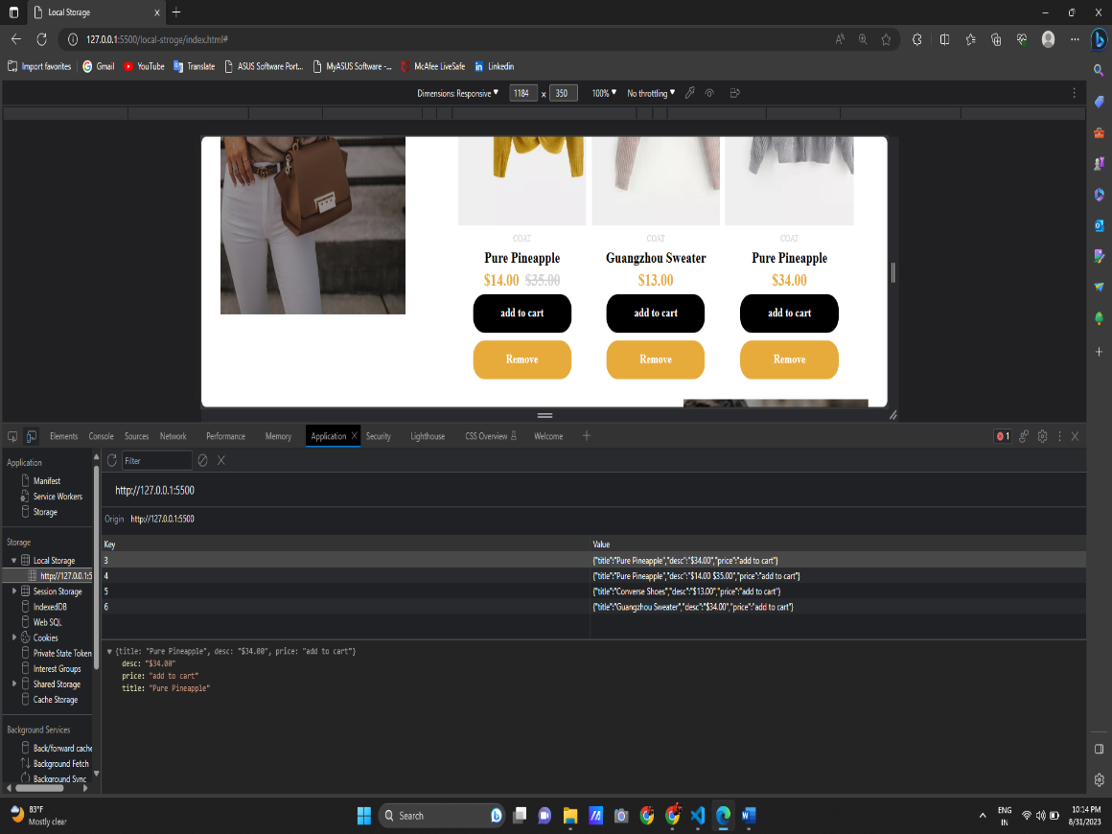

Fig 8.3

The above HTML structure and JavaScript code appear to be part of an e-commerce website's frontend. It looks like this code focuses on displaying product items and implementing functionality related to adding and removing items from a shopping cart using Local Storage. Let's discuss the key features and the code's functionality:

1. **Key Features:**
   * **Women's Collection and Men's Collection:** The website seems to have separate sections for women's and men's collections, each with their own product listings and cover images.
   * **Product Listings:** The website displays product listings with product images, titles, descriptions, prices, and buttons for adding and removing items from the cart.
   * **Quick View and Wishlist:** The product listings include quick view and wishlist icons, allowing users to see details quickly and add items to their wishlist.
   * **Local Storage:** The code uses the Local Storage API to store product information temporarily in the browser. This enables the website to remember the user's cart even after page refreshes or closing the browser.
2. **JavaScript Functionality:**
   * The **addCart** function is triggered when a user clicks the "Add to Cart" button for a product. It collects the title, description, and price of the product based on the provided **id**. It then creates an object with this information and stores it in the browser's Local Storage using the **localStorage.setItem** method.
   * The **removeCart** function is triggered when a user clicks the "Remove" button for a product. It removes the product information associated with the provided **id** from the Local Storage using the **localStorage.removeItem** method.

# CHAPTER 9 – FAKE API

It seems like you're interested in creating a fake API using JavaScript. A fake API is often used for development and testing purposes when you don't have access to a real API or want to simulate specific responses.

we create a **fakeData** array containing some simulated data. We use the **simulateNetworkDelay** function to introduce a delay to mimic network latency. The **getFakeData** function returns a promise that resolves with the **fakeData** after the simulated delay. Finally, we use the **getFakeData** function and handle the data or error using **.then()** and **.catch()**.

Keep in mind that this is a very basic example, and in a real-world scenario, you might want to implement more complex behaviors, handle different HTTP methods (GET, POST, PUT, DELETE), and possibly even use a library like JSON Server for more advanced fake API capabilities.

This chapter marks an exploration into the dynamic world of data retrieval using the Fetch API, with a focus on integrating the Fake Store API. Throughout my internship, I had the chance to work with the Fetch API, a powerful tool that facilitates fetching data from remote sources. In this chapter, I will unravel the mechanics of how the Fetch API operates, enabling seamless data retrieval and interaction. I will delve into the practical aspects of using the Fetch API to connect with the Fake Store API, an artificial data source. This allows web applications to retrieve product information and seamlessly display it to users. By understanding the workflow and syntax of using the Fetch API, readers will gain insights into how external data can be integrated into web projects. The "FakeStore API" is a free, public API that provides mock data related to an e-commerce store. It is often used for testing, learning, and development purposes. The API includes various endpoints that allow you to retrieve information about products, categories, and users as if it were a real online store.

Here is a brief introduction to the FakeStore API: Base URL: <https://fakestoreapi.com>

1. `/products`: Returns a list of products available in the store, each with details like ID, title, price, Description, category, and image URL.

2. `/products/{id}`: Returns the details of a specific product based on its ID.

3. `/categories`: Returns a list of product categories.

4. `/categories/{category}`: Returns a list of products belonging to a specific category.

5. `/users`: Returns a list of mock user profiles. Products json data: { "id": 1, "title": "Fjallraven - Foldsack No. 1 Backpack, Fits 15 Laptops", G.E.C RAJKOT "price": 109.95, "description": "Your perfect pack for everyday use and walks in the forest. Stash your laptop (up to 15 inches) in the padded sleeve, your everyday", "category": "men's clothing", "image": "https://fakestoreapi.com/img/81fPKd-2AYL._AC_SL1500_.jpg", }

**CREATING NEWS-WEBSITE USING FAKE API**

It sounds like you're interested in creating a news website using a fake API with JavaScript. Using a fake API can be a great way to prototype and develop your website before integrating it with a real API. Here's a general outline of how you could achieve this:

1. Set Up Your Project: Start by creating a project directory and setting up the basic structure. You'll need HTML, CSS, and JavaScript files.
2. Create HTML Structure: Design the layout of your news website using HTML. Create sections for headlines, articles, and other components you want to include.
3. Style Your Website: Use CSS to style your website and make it visually appealing. You can use frameworks like Bootstrap or CSS preprocessors like SASS to streamline the process.
4. Create a Fake API: Since you're using a fake API, you won't have a real backend. Instead, you can create a mock JSON file that simulates the response you would get from a real API. The JSON file should include data like article titles, content, authors, and other relevant information.
5. Fetch Data with JavaScript: Use JavaScript's Fetch API or other AJAX methods to retrieve data from your fake API (the mock JSON file). Parse the JSON response and dynamically populate your website with the retrieved information.

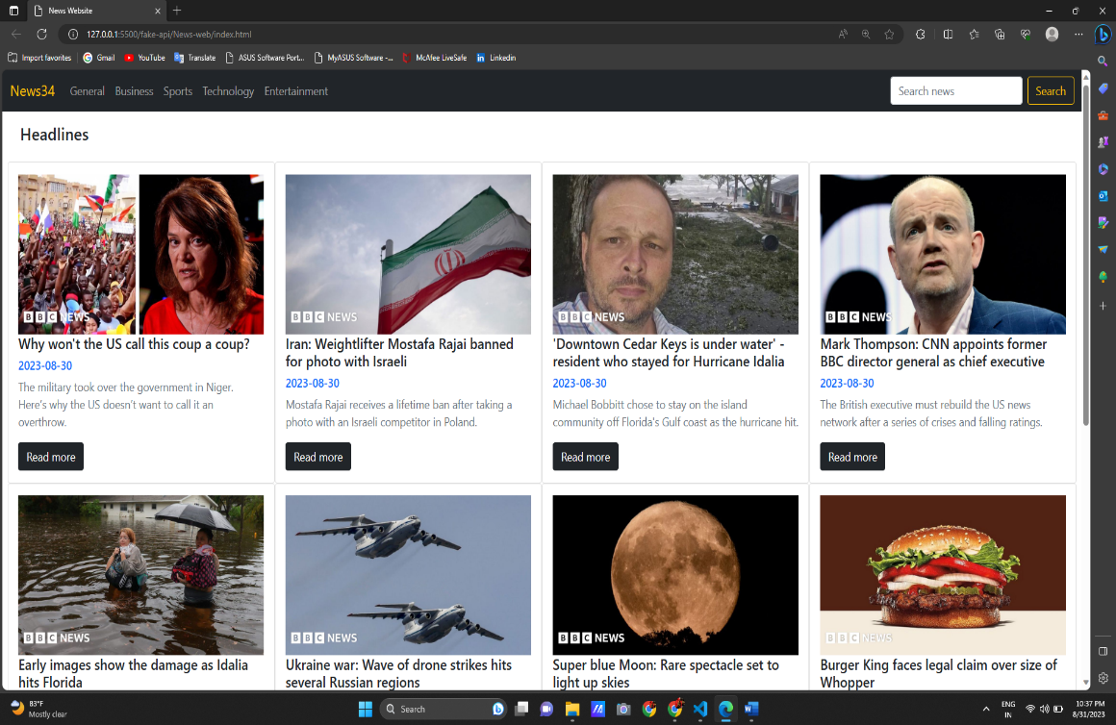

Fig 9.1

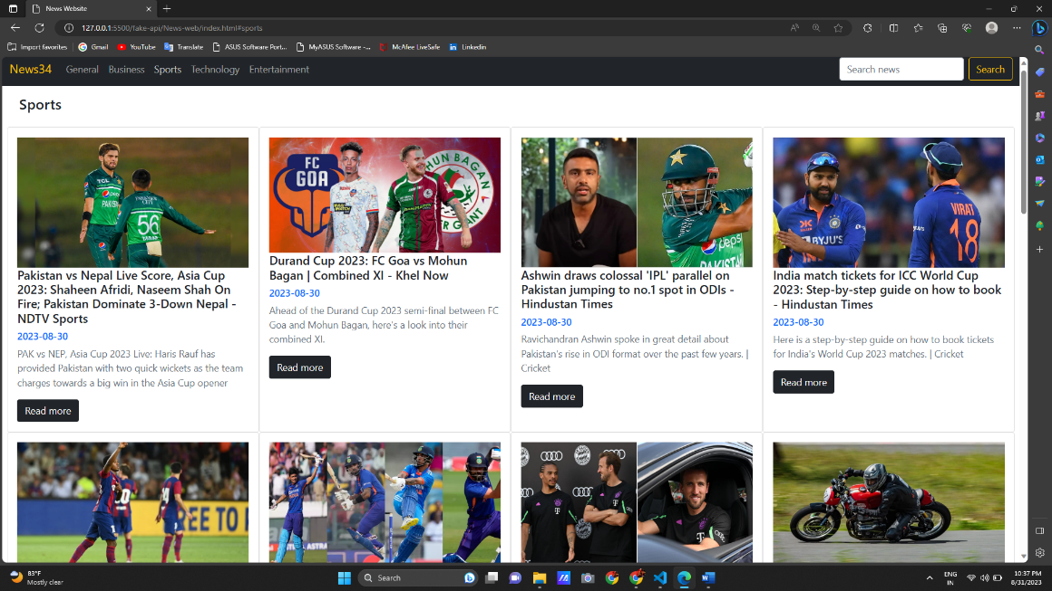

Fig 9.2

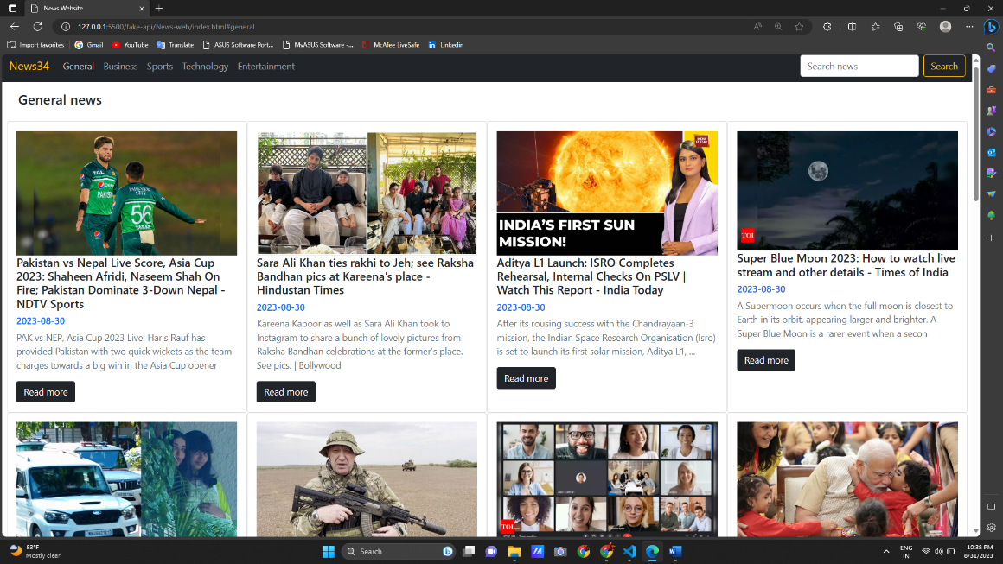

Fig 9.3

a news website that fetches and displays news articles using the News API. This API allows you to retrieve news articles from various sources and categories. Here's a breakdown of how the code works:

1. **HTML Structure:** The HTML structure you provided contains the layout of your news website, including a navigation bar, placeholders for different types of news, and a search feature.
2. **JavaScript Logic (script.js):** This is where you've implemented the logic to fetch and display news articles using the News API. Here's a step-by-step breakdown of the JavaScript logic:
   * The script starts by defining various elements from your HTML using **getElementById**.
   * It sets up event listeners for different buttons (e.g., General, Business, Sports) and the search button.
   * It defines constants for API endpoints and your API key.
   * The **fetchHeadlines** function fetches top headlines using the News API.
   * Similar functions (**fetchGeneralNews**, **fetchBusinessNews**, etc.) fetch news for specific categories.
   * The **displayNews** function populates the news articles in the respective HTML elements. It loops through the fetched news data and creates elements for each news article, including the title, date, description, and a link to the full article.

* **Initialization:** The **window.onload** function calls the **fetchHeadlines** function when the page loads, displaying the top headlines.
* **Event Listeners:** Each category button (e.g., General, Business) has an associated event listener. When you click a category button, the corresponding fetch function is called, and the news data is displayed using the **displayNews** function.
* **Search Button:** When you enter a search query and click the search button, the **fetchQueryNews** function (which seems to be missing from the code you provided) should be implemented. This function should fetch news based on the search query and display the results.

# CONCLUSION

The end of a dynamic 15-day journey into the world of web development. Throughout my internship, I was immersed in a rich tapestry of technologies, concepts, and practical experiences that have significantly expanded my skill set and perspectives.

The practical exposure to technologies like HTML CSS and Local Storage and APIs has bolstered my confidence as a web developer. In retrospect, I am immensely grateful for the guidance and mentorship provided by my supervisor and the entire team at e seller hub. Their support fostered an environment of continuous learning, encouraging me to explore new technologies and push my boundaries.

I extend my gratitude to all those who contributed to this enriching experience and look forward to applying these lessons in the dynamic landscape of web development.

# REFERENCES

* + - [www.w3schools.com](http://www.w3schools.com/)
    - <https://fakestoreapi.com/about>
    - https://w3layouts.com/